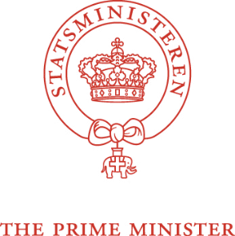**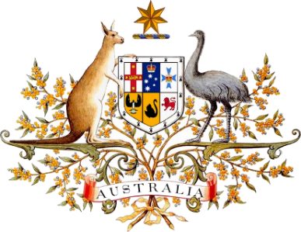Australia-Denmark**

**Strategic Partnership Arrangement**

Today, the Prime Minister of Australia and the Prime Minister of Denmark reaffirmed their commitment to strengthening the bilateral relationship based on mutual trust and respect.

Since establishing diplomatic relations in 1967, Australia and Denmark have forged ever-closer bonds. We share a firm commitment to universal human rights, democracy, the rights of First Nations and Indigenous peoples, gender equality, free trade, ambitious action on climate change and protection of the rules and norms of international law.

We seek a world where sovereignty and a country’s right to make its own decisions are respected. Australia and Denmark will promote a more peaceful, secure, and sustainable world and advance our common values and interests.

Australia and Denmark will explore opportunities for cooperation across three pillars:

1. Advancing action on climate change and green transition
2. Promoting peace and security as we engage in a changing geopolitical environment
3. Enhancing collaboration in areas of strategic importance.

**1. Advancing action on climate change and enhancing green transition**

The changing climate is an immediate global challenge. Australia and Denmark share a focus on delivering on the 2030 Agenda for Sustainable Development and the Paris Agreement. Both countries have legislated their 2030 target and committed to pursuing efforts to limit temperature increase to 1.5 degrees above pre-industrial levels as set out in the Paris Agreement.

There is a need for like-minded countries to work together internationally to ensure increasingly ambitious goals on mitigation and support countries to transition towards lower emission energy systems.

Australia and Denmark have a shared interest in working collaboratively to advance the green transition, including through maximising the opportunities presented by the comprehensive and ambitious trade agreement between the EU and Australia. Seizing the opportunities presented by the agreement, when concluded, will be an ongoing endeavour.

Australia and Denmark reaffirm our international commitments on addressing climate change by strengthening efforts on mitigation, adaptation, and resilience.

Australia and Denmark will seek to:

* 1. expand cooperation on ambitious global action and policy to meet obligations under theGlasgow Climate Pact and Paris Agreement
  2. promote renewable energy including solar, hydro and wind via initiatives such as the Global Offshore Wind Alliance
  3. support vulnerable countries adapt to climate change
  4. explore options to deepen green transition partnerships and energy efficiency measures including in water, food, and agriculture
  5. explore opportunities for collaboration on green hydrogen, green shipping corridors and carbon neutral shipping through Mission Innovation and the International Maritime Organization.

Australia and Denmark recognise the growing demand for critical minerals needed in the transition towards clean energy and endorse further collaboration in this area.

**2. Promoting peace and security in a changing strategic environment**

The changing global strategic environment challenges stability, economic prosperity, and the international rules-based order. As like-minded countries, Australia and Denmark understand the importance of increased collaboration at the multilateral level, to ensure a stable geostrategic balance that allows for a peaceful, prosperous, and secure world.

Australia and Denmark will:

* 1. work toward an open, stable, and prosperous world, which upholds sovereignty and international law and norms
  2. engage in line with national priorities to build prosperity, sustainability, connectivity, and resilience
  3. uphold the rule of law, human rights, and rights and obligations [including freedom of navigation and overflight] under the United Nations Convention of the Law of the Sea (UNCLOS)
  4. cooperate with like-minded partners to reinforce and strengthen the rules-based multilateral trading system to maintain open markets, build more resilient supply chains and respond to economic coercion
  5. promote a global, open, free, stable, and secure cyberspace
  6. explore opportunities to counter foreign interference and violent extremism
  7. encourage defence and security cooperation including implementation of the Women, Peace and Security agenda, knowledge sharing and business cooperation within the defence, academia and civil industry.

**3. Enhancing collaboration in areas of strategic importance**

The challenges of the future highlight the need for collaboration in new areas of strategic importance. Australia and Denmark understand the benefits of expanding trade, investment and research opportunities particularly in strategically important areas such as critical minerals, biotechnology, the maritime sector and pharmaceuticals, and quantum technology.

Australia and Denmark will:

* 1. encourage research cooperation on critical and emerging technologyrelevant for the green transition of societies and collaboration in multilateral health fora to address global public health challenges
  2. explore opportunities on critical IT-infrastructure and quantum technology
  3. support trade and investment collaboration including in natural resources, critical minerals, maritime technology, and agriculture.

Australia and Denmark commend and encourage the deep and diverse cultural, educational, and scientific exchanges between universities, research institutions and think tanks, as well as between cultural and sporting organisations. The links form the essential foundations of our strong bilateral relationship.

The initiatives under this strategic partnership will be assessed in annual bilateral consultations between officials of Australia’s Department of Foreign Affairs and Trade and Denmark’s Ministry of Foreign Affairs, as well as other agencies and experts, where relevant.

Signed in Vilnius on XX July 2023.

|  |  |
| --- | --- |
| **For the Government of Australia** | **For the Government of the  Kingdom of Denmark** |
| ___________________________________  The Honourable Anthony Albanese MP Prime Minister | __________________________________  Mette Frederiksen, MP  Prime Minister |